Watch for Flea Beetles this Spring

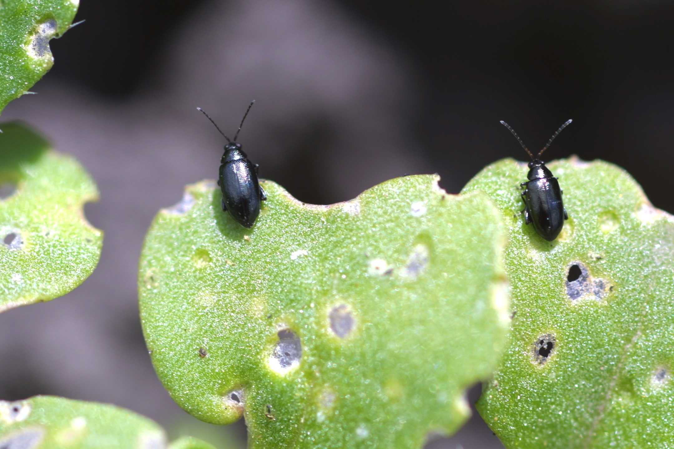
Once canola starts to emerge, start scouting for flea beetles. Flea beetles are now very active and present in emerged canola. Canola will emerge quickly with forecast temperatures in high teens for the next week. Flea beetle damage is most severe the first two weeks after canola seedling emergence. At the 3-4 leaf stage the plants can generally outgrow the feeing damage.
Crucifer Flea Beetle

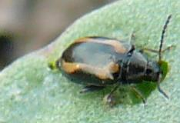
Early Planted Canola may need early control. Very early planted canola stands may be thin and have been stressed by cold temperatures/frost and slow emergence. Stressed canola stands will be less tolerant of added stress from flea beetle damage. In addition seed treatments may no longer be providing protection.
Striped Flea Beetle

Seed treatments provide 14 -21 days protection against low to moderate flea beetle pressure. Flea beetles must take a bite from the plant to die, so expect to see some feeding damage. However under heavy or sustained pressure, seed treatment may not provide adequate control. Flea beetle damage at threshold levels can occur before weed control timing depending on how quickly the crop develops.

Damage: appears as shot holes or pitting in leaves and stem feeding leading to reduced and weaker stands.

Scout field margins and early emerging weeds like stinkweed, wild mustard, pennycress and lambsquarter, where flea beetles usually appear first. When scouting, it is important to understand that flea beetles generally invade canola fields from the field edges. Under cool temperatures flea beetles stay close to soil surface, but become active and fly in search of food on warm sunny days. Under cool, cloudy weather look for damage on underside of leaves and stem below the cotyledon where flea beetles will be more active.

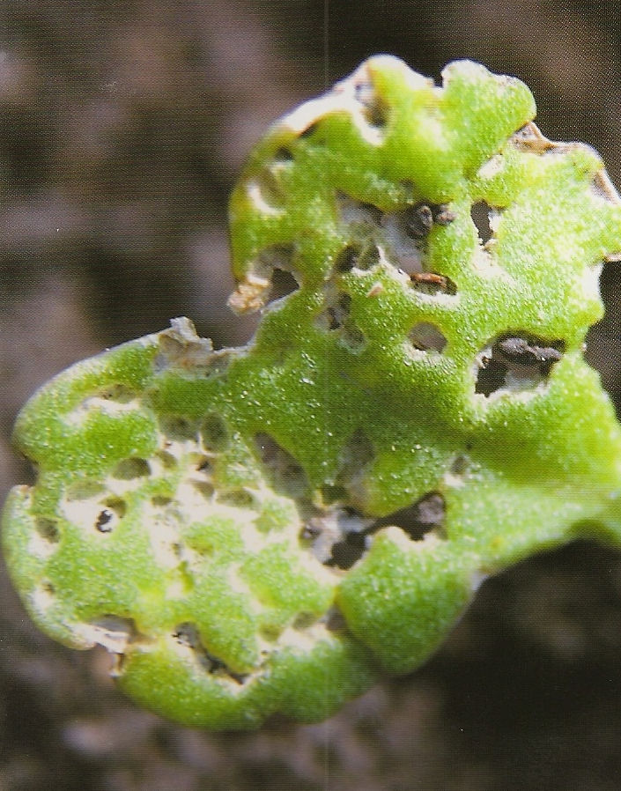
Scout every 2-3 days in warm and sunny weather, because threshold levels can be quickly reached.
25% flea beetle damage

Control:
Control is warranted when there is 25% of the surface leaf area damaged. Foliar products have a short residual and may only give 3- 4 days of protection. Multiple applications may be necessary for high infestations. If damage exceeding threshold numbers are reached in only field margins, a foliar spray may only be required for that are. However under warm, calm weather, flea beetles take flight and may cause damage further into the field.

